,,:~~~~~,~---·-~--
~
'-, '--~~ ,. 1. c.
THE ACCOUNTS FOR THE MANOR OF ESHER IN THE WINCHESTER PIPE ROLLS, 1235-1376
29 September 1235 to c. 29 September 1236
. . the first account for Esher that appears on the Winchester Pipe Rolls. As there Th1s 1s . . p in the rolls between 1232/3 and 1235/6, 1t seems likely that Esher was is a ga . ^{n h fi} . purchased by B1shop Peter des .1'-0C es rom the abbey of Cr01.x St Leufroy at some
. t between 29 September 1233 and 29 September 1235. Since the Esher account pom ' d' ' h • c. h •
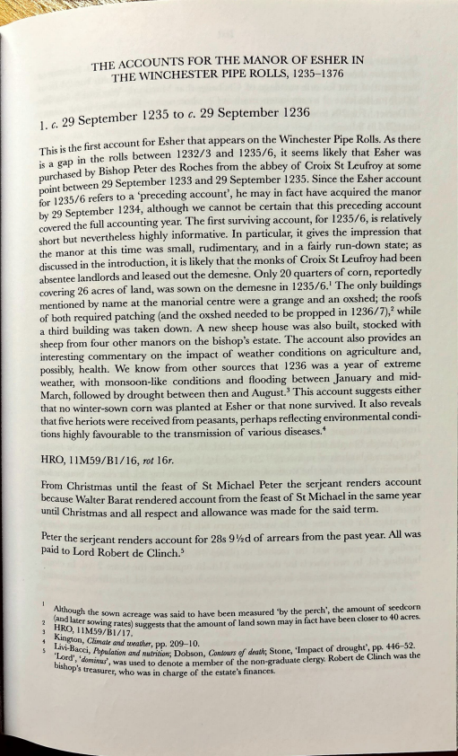
for 1235/6 refers to a prece mg account, e may m 1act ave acqurred the manor by 29 September 1234, although we cannot be certain that this preceding account covered the füll accounting year. The first surviving account, for 1235/6, is relatively short but nevertheless highly informative. In particular, it gives the impression that the manor at this time was small, rudimentary, and in a fairly run-down state; as discussed in the introduction, it is likely that ~he monks of Croix St Leufroy had been absentee landlords and leased out the demesne. Only 20 quarters of corn, reportedly covering 26 acres of land, was sown on the demesne in 1235/6. ¹ The only buildings mentioned by name at the manorial centre were a grange and an oxshed; the roofs of both required patching (and the oxshed needed tobe propped in 1236/7),² while a third building was taken down. A new sheep house was also built, stocked with sheep from four other manors on the bishop's estate. The account also provides an interesting commentary on the impact of weather conditions on agriculture and, possibly, health. We know from other sources that 1236 was a year of extreme weather, with monsoon-like conditions and flooding between January and mid March, followed by drought between then and August. ³ This account suggests either that no winter-sown corn was planted at Esher or that none survived. lt also reveals that five heriots were received from peasants, perhaps reflecting environmental condi tions highly favourable to the transmission of various diseases. ⁴
HRO, l 1M59/Bl/16, rot 16r.
From Christmas until the feast of St Michael Peter the serjeant renders account because Walter Barat rendered account from the feast of St Michael in the same year until Christmas and all respect and allowance was made for the said term. All
. e serJeant renders account for 28s 9 ½d of arrears from the past year. was
Peter th •
paid to Lord Robert de Clinch. 5
Although th . , f d a d 1 e sown acreage was sa1d to have been measured 'by the perch , the amount o see corn 2 n ater s • I 40
(
liRO owmg rates) suggests that the amount of land sown may in fact have been c oser to acres. 3 Kin , l lM59/Bl/I 7.
t Livi~on, _Climate and wealher, pp. 209-10.
Pulatwn and nutritwn· Dobson Co11tours or deatk Stone, 'Impact of drought', PP· ₄⁴6-52. 5 'Lord'a~i, 1:⁰
domi ' ' ' ⁰ ' d c1· h h bisho ', nus, was used to denote a member of the non-graduale clergy. Robert e mc was t e P s treasure h · r, w o was m charge of the estate's finances.
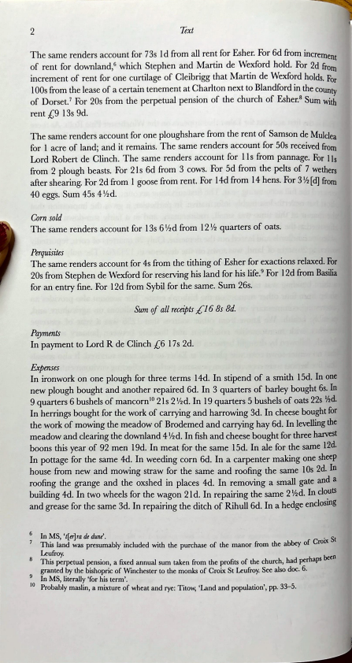
2 ^{Text}
The same renders account for 73s ld from all rent for Esher. For 6d from increment of rent for downland, ⁶ which Stephen and Martin de Wexford hold. For 2d frorn increment of rent for one curtilage of Cleibrigg that Martin de Wexford holds. For 1 OOs from the lease of a certain tenement at Charlton next to Blandford in the county of Dorset.⁷ For 20s from the perpetual pension of the church of Esher.⁸ Sum with rent [,9 13s 9d.
The same renders account for one ploughshare from the rent of Samson de Mulclea for 1 acre of land; and it remains. The same renders account for 50s received frorn Lord Robert de Clinch. The same renders account for 11 s from pannage. For l ls from 2 plough beasts. For 21 s 6d from 3 cows. For 5d from the pelts of 7 wethers after shearing. For 2d from 1 goose from rent. For 14d from 14 hens. For 3 ½ ( d] from 40 eggs. Sum 45s 4 ½d.
Corn sold
The same renders account for 13s 6 ½d from 12 ½ quarters of oats.
Perquisites
The same renders account for 4s from the tithing of Esher for exactions relaxed. For 20s from Stephen de Wexford for reserving bis land for his life. ⁹ For 12d from Basilia for an entry fine. For 12d from Sybil for the same. Sum 26s.
Sum of all recdpts ;[' 16 Bs Bd.
Payments
In payment to Lord R de Clinch [,6 1 7 s 2d.
Expenses
In ironwork on one plough for three terms 14d. In stipend of a smith 15d. In one new plough bought and another repaired 6d. In 3 quarters of barley bought 6s. In 9 quarters 6 bushels of mancorn¹⁰ 21s 2 ½d. In 19 quarters 5 bushels of oats 22s ½d. In herrings bought for the work of carrying and harrowing 3d. In cheese bought for the work of mowing the meadow of Brodemed and carrying hay 6d. In levelling the meadow and clearing the downland 4 ½d. In fish and cheese bought for three harvest boons this year of 92 men 19d. In meat for the same 15d. In ale for the same 12d. In pottage for the same 4d. In weeding corn 6d. In a carpenter making one sheep house from new and mowing straw for the same and roofing the same 1 Os 2d. In roofing the grange and the oxshed in places 4d. In removing a small gate and a building 4d. In two wheels for the wagon 21 d. In repairing the same 2 ½d. In cl~uts and grease for the same 3d. In repairing the ditch of Rihull 6d. In a hedge enclosmg
6 In MS, 't[er]ra de duni. . S 7 This land was presumably included with the purchase of the manor from the abbey of Croix t Leufroy. ₈ This perpetual pension, a fixed annual sum taken from the profits of the church, had perhaps been
granted by the bishopric of Winchester to the monks of Croix St Leufroy. See also doc. 6. 9 In MS, literally 'for his term'.
IO Probably maslin, a mixture of wheat and rye: Titow, 'Land and population', pp. 33-5.
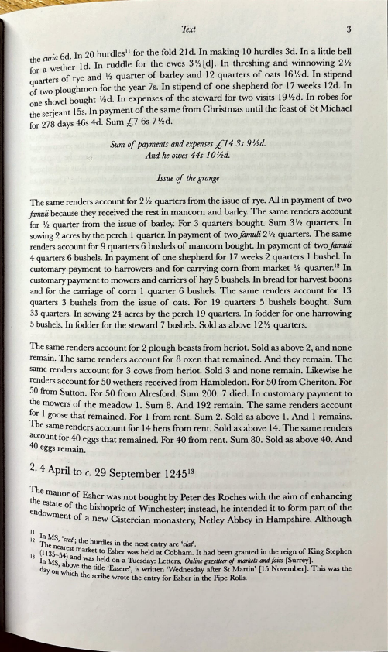
Text 3
• 6d In 20 hurdles ¹¹ for the fold 21 d. In making 10 hurdles 3d. In a little bell t^{h}e cuna the.r 1 d In ruddle for the ewes 3 ½ [ d]. In threshing and winnowing 2 ½ for a we •
uarters of rye and ½ quarter of barley and 12 quarters of oats 16 ½d. In stipend qf _{O} ploughmen for the year 7s. In stipend of one shepherd for 17 weeks 12d. In 0 twhovel bought ½d. In expenses of the steward for two visits 19 ½d. In rohes for one s . . . the serjeant 15s. In payment of the same from Chnstmas until the feast of St Michael for 278 days 46s 4d. Sum [,7 6s 7 ¹
/2d.
Sum of payments and expenses ;f:14 3s 9½d.
,t And he owes 44s JO½d.
lssue of the grange
The same renders account for 2 ½ quarters from the issue of rye. All in payment of two Jamua because they received the rest in mancorn and barley. The same renders account for ½ quarter from the issue of barley. For 3 quarters bought. Sum 3 ½ quarters. In sowing 2 acres by the perch 1 quarter. In payment of two famuli 2 ½ quarters. The same renders account for 9 quarters 6 bushels of mancorn bought. In payment of two f amuli 4 quarters 6 bushels. In payment of one shepherd for 1 7 weeks 2 quarters 1 bushel. In customary payment to harrowers and for carrying corn from market ½ quarter. ¹² In customary payment to mowers and carriers of hay 5 bushels. In bread for harvest boons and for the carriage of corn 1 quarter 6 bushels. The same renders account for 13 quarters 3 bushels from the issue of oats. For 19 quarters 5 bushels bought. Sum 33 quarters. In sowing 24 acres by the perch 19 quarters. In fodder for one harrowing 5 bushels. In fodder for the steward 7 bushels. Sold as above 12 ½ quarters.
The same renders account for 2 plough beasts from heriot. Sold as above 2, and none remain. The same renders account for 8 oxen that remained. And they remain. The same renders account for 3 cows from heriot. Sold 3 and none remain. Likewise he renders account for 50 wethers received from Hambledon. For 50 from Cheriton. For SO from Sutton. For 50 from Alresford. Sum 200. 7 died. In customary payment to t^{h}e mowers of the meadow 1. Sum 8. And 192 remain. The same renders account *r ^{I} goose that remained. For 1 from rent. Sum 2. Sold as above 1. And 1 remains.
he same renders account for 14 hens from rent. Sold as above 14. The same renders :~count for 40 eggs that remained. For 40 from rent. Sum 80. Sold as above 40. And eggs remain.
2 4 A il • pr to c. 29 September 1245¹³
Themano f Eh _{the r} O s er was not bought by Peter des Roches with the aim of enhancing estate of the b. h • f w· . . . c: f h _{endo} ¹s opnc o mchester; mstead, he mtended 1t to 1orm part o t e Wrnent of a new Cistercian monastery, Netley Abbey in Hampshire. Although
II
In MS, 'craf· ₁₂ Thc nc ' t^{h}e hurdles in the next entry are 'c/af.
13 {1135-~)^{st} ~arket to Esher was held at Cobham. lt had been granted in the reign of King Stephen
In MS a~ was _held on a Tuesday: Letters, Online gazett«r of marktts andjairs [Surrey]. day 0; whi : :e tttl_e 'Essere', is written 'Wednesday after St Martin' [15 November). This was the c e scnbe wrote the entry for Esher in the Pipe Rolls.

